Factions

Factions are groups of people who share similar political beliefs and aspirations. Members of a faction take action to support these beliefs.

There are five known factions in Faerûn.

1. The Harpers
2. The Order of the Gauntlet
3. The Emerald Enclave
4. The Lords’ Alliance
5. The Zhentarim

These factions are organizations that have risen, been shattered, and risen again several times. Their longevity and resilience are largely due to their grassroots, secretive nature, and the near-autonomy of many of its members. The Harpers, for instance, have “cells” and lone operatives throughout Faerûn, although they interact and share information with one another from time to time as needs warrant. With the Zhentarim, their public face appears more benign than their otherwise power-hungry natures, offering the best mercenaries that money can buy. Whether noble warriors, rugged survivalists, or deceptive agents, your choice to join a player faction will help shape your involvement in the game's ongoing story.

Joining a Faction

At some point in an adventurer’s life, they may have the opportunity to join with one of the factions in the world. Generally, a faction representative will reach out to candidates they see as a “good fit” for their faction based on what that faction believes. However, those factions that operate openly will generally also consider adventurers who approach them.

Most adventurers see joining a faction as a good thing. Factions are global organizations with significant resources that they use to support the work of their members. However, that support comes at a cost, at any time the faction might call upon it’s members to take action in service of the faction’s needs. Factions also pay attention to the actions of it’s members, especially if those actions openly reflect upon the faction as a whole.

An adventurer may have the opportunity to join multiple factions and there is nothing stopping them from doing so. However, factions frown upon this deeply. If a faction learns that a member has joined with another faction it usually does not end well for the adventurer who is trying to play both sides. At a minimum they will likely find themselves being asked by one faction to act in defiance of the beliefs of the other.

Renown

Over the course of your adventures, your actions have an impact on the world around you. For example, news of your actions might either impress or anger certain factions in the world.

Renown is a measurement of how people feel about your overall actions in the past. Your Renown with a faction can increase or decrease based on the extent to which news of your actions is (or isn’t) inline with a given faction’s beliefs and aspirations. You need not be a member of a faction to gain (or loose) Renown with them. In fact, because the nature of the known factions quite often the same actions that gain Renown with one faction will loose Renown with another.

More info

The following page provides a place where you can keep track of your renown and other notes related to each faction. Print this out and add it to your character sheet.

Further info regarding each faction will become available to those who are approached by them.

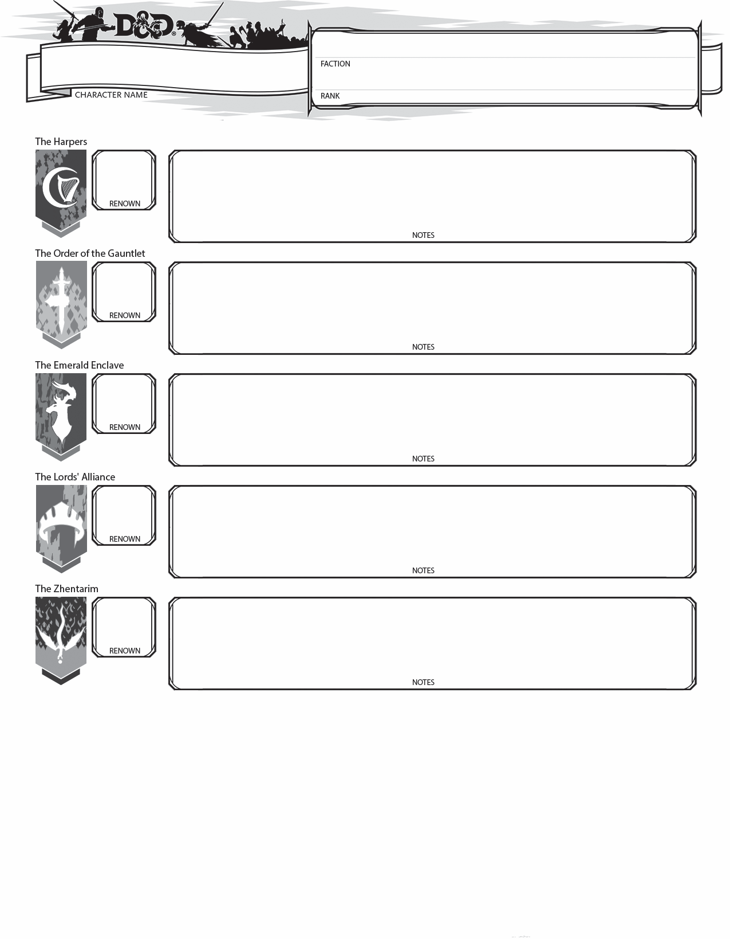

The Harpers

Overview:

The Harpers is an old organization that has risen, been shattered, and risen again several times. Its longevity and resilience are largely due to its decentralized, grassroots, secretive nature, and the near-autonomy of many of its members. The Harpers have “cells” and lone operatives throughout Faerûn, although they interact and share information with one another from time to time as needs warrant. The Harpers' ideology is noble, and its members pride themselves on their integrity and incorruptibility. Harpers do not seek power or glory, only fair and equal treatment for all.

Harper agents are trained to act alone and depend on their own resources. When they get into scrapes, they don’t count on their fellow Harpers to rescue them. Nevertheless, Harpers are dedicated to helping one another in times of need, and friendships between Harpers are nigh unbreakable. Masterful spies and infiltrators, they use various guises and secret identities to form relationships, cultivate their information networks, and manipulate others into doing what needs to be done. Although most Harpers prefer to operate in the shadows, there are exceptions.

Motto:

“Down with tyranny. Fairness and equality for all”

Beliefs:

One can never have too much information

Too much power leads to corruption

No one should be powerless

Goals:

To gather information throughout Faerun, discern the political dynamics within each region or realm, and promote fairness and equality by covert means. Act openly as a last resort. Thwart tyrants and any leader, government, or group that grows too powerful, and aid the weak, the poor and the oppressed

References:

<http://forgottenrealms.wikia.com/wiki/Harpers>



**High Harper**

*You have done so much to further the cause of The Harpers that the High Harpers now count you as one of them. Your council will be critical in determining the future course of The Harpers.*

**Requirements:**

Renown score of 50 with the Harpers

The endorsement of all High Harpers

**Benefits of this title are:**

As a High Harper you have the full strength of The Harper’s organization. You are able to **call on a small army**, **take custody of rare magic items**, **call upon a specialty spellcaster**, and **assign missions to lower ranking Harpers**.

**Follower**

Followers are usually non-adventuring people who identify with the cause of an adventurer.

As such, a follower is not one to engage in heavy adventuring nor combat and most Harpers would feel too responsible for their follower’s well being to ask them to.

Instead a follower will travel but remain in town and acting on the adventurer’s behalf.

A follower might make a run to the local trading post to purchase supplies, secure lodging or become acquainted with local rumors and notable citizens of the town. On the road a follower will make and break camp, cook meals and take a watch shift.

Those who take on a follower usually feel a deep responsibility for their well being and a respect for their choice to aid them.

**Wise Owl**

*The High Harpers have convened and due to your hand in furthering the goals of The Harpers they have decided to promote you to Wise Owl. All Harpers will now know of you by name. Take care not to disappoint them.*

**Requirements:**

Renown score of 25 with the Harpers

The endorsement of a majority of High Harpers

**Benefits of this title are:**

You have been given authorization by a High Harper to recruit a **follower** to aid you in your adventures.

**Brightcandle**

*Congratulations Harpershadow… your deeds have caught the attention of a High Harper and they believe you to be a promising rising star of the organization.*

**Requirements:**

Renown score of 10 with the Harpers

The endorsement of a High Harper

**Benefits of this title are:**

You have access to the secret **backroom stock** of any Harper affiliated merchant. The backroom stock is a set of equipment, potions and scrolls an adventurer may need while operating within the local in which the merchant conducts business.

Items in the backroom stock are the property of The Harpers and are therefore free to the Harper. The merchant is simply providing a place to keep these good safe and in stock.

**Harpershadow**

*Your actions have been noticed by a Wise Owl of The Harpers and they have promoted you.*

**Requirements:**

Renown score of 3 with the Harpers

The endorsement of a Wise Owl

**Benefits of this title are:**

In any city, town or village where The Harpers have a presence, you can make **contact with a faction representative** through whom you can communicate with the Harper’s leadership and secure lodging for yourself at a faction safehouse.

**Watcher**

*As a new member of the Harper’s organization you are bestowed the title of “Watcher”.*

**Requirements:**

Renown score of 1 with the Harpers

The endorsement of a Brightcandle

**Benefits of this title are:**

You are given a **Symbol of the Harpers**, a pin amulet or coin emblazoned with the Harper’s logo. This is used to prove your identity to other Harpers who may look kindly on a fellow Harper.

For example, a Harper who also happens to run a trading post may offer discounts to fellow Harpers.

The Order of the Gauntlet

Overview:

Many paladins and clerics of Tyr, Helm, Torm, and Hoar have joined the organization, seeing it as—finally!—a way of making common cause against the evils abroad in the world. The Order of the Gauntlet is ready to lash out the moment evil acts, and not a moment before. When evil breaks laws, agreements, or commonly accepted codes of conduct, the Gauntlet strikes hard and fast, without waiting for the blessings of distant temples or the permission of rulers. Evil must be met in the field and smashed, or it will swiftly overcome all.

The Order of the Gauntlet is a dedicated, tightly knit group of like-minded individuals driven by religious zeal or a finely honed sense of justice. Friendship and camaraderie are important to members of the Order of the Gauntlet, and they share a trust and a bond normally reserved for siblings. Like highly motivated soldiers, members of the Order of the Gauntlet seek to become the best at what they do and look forward to testing their mettle. There are few, if any, “lone wolves” in this organization.

Motto:

"When evil strikes, we strike back."

Beliefs:

Faith is the greatest weapon against evil—faith in one’s god, one’s friends, and one’s self.

Battling evil is an extraordinary task that requires extraordinary strength and bravery.

Punishing an evil act is just. Punishing an evil thought is not.

Goals:

To be armed, vigilant, and ready to smite evil, enforce justice, and enact retribution. This means identifying evil threats such as secretive power groups and inherently evil creatures, watching over them, and being ready to attack the moment they misbehave. (These are always retributive strikes, never preemptive.)

References:

<http://forgottenrealms.wikia.com/wiki/Order_of_the_Gauntlet>



**Vindicator**

*The Righteous Hands have convened and due to your hand in furthering the goals of The Order of the Gauntlet they have decided to promote you to Vindicator. All Order members will now know of you by name. Take care not to disappoint them.*

**Requirements:**

Renown score of 25 with the Order of the Gauntlet

The endorsement of a majority of Righteous Hands

**Benefits of this title are:**

You have been given authorization by a Righteous Hand to recruit a **follower** to aid you in your adventures.

**Follower**

Followers are usually non-adventuring people who identify with the cause of an adventurer.

As such, a follower is not one to engage in heavy adventuring nor combat and most Adventurers would feel too responsible for their follower’s well being to ask them to.

Instead a follower will travel but remain in town and acting on the adventurer’s behalf.

A follower might make a run to the local trading post to purchase supplies, secure lodging or become acquainted with local rumors and notable citizens of the town. On the road a follower will make and break camp, cook meals and take a watch shift.

Those who take on a follower usually feel a deep responsibility for their well being and a respect for their choice to aid them.

**Righteous Hand**

*You have done so much to further the cause of The Order of the Gauntlet that the Righteous Hands now count you as one of them. Your council will be critical in determining the future course of The Order of the Gauntlet.*

**Requirements:**

Renown score of 50 with the Order of the Gauntlet

The endorsement of all Righteous Hands

**Benefits of this title are:**

As a Righteous Hand you have the full strength of The Order of the Gauntlet. You are able to **call on a small army**, **take custody of rare magic items**, **call upon a specialty spellcaster**, and **assign missions to lower ranking Order members**.

**Whitehawk**

*Congratulations Marcheon… your deeds have caught the attention of a Righteous Hand and they believe you to be a promising rising star of the organization.*

**Requirements:**

Renown score of 10 with the Order of the Gauntlet

The endorsement of a Righteous Hand

**Benefits of this title are:**

You have access to the secret **backroom stock** of any Order affiliated merchant. The backroom stock is a set of equipment, potions and scrolls an adventurer may need while operating within the local in which the merchant conducts business.

Items in the backroom stock are the property of The Order. The merchant is simply providing a place to keep these good safe and in stock.

**Marcheon**

*Your actions have been noticed by a Vindicator of The Order of the Gauntlet and they have promoted you.*

**Requirements:**

Renown score of 3 with the Order of the Gauntlet

The endorsement of a Vindicator

**Benefits of this title are:**

In any city, town or village where The Order of the Gauntlet have a presence, you can make **contact with a faction representative** through whom you can communicate with the Order’s leadership and secure lodging for yourself at a faction safehouse.

**Chevall**

*As a new member of the Order of the Gauntlet organization you are bestowed the title of “Chevall”.*

**Requirements:**

Renown score of 1 with the Order of the Gauntlet

The endorsement of a Whitehawk

**Benefits of this title are:**

You are given a **Symbol of the Gauntlet**, a pin amulet or coin emblazoned with the Order’s logo. This is used to prove your identity to other Order members who may look kindly on a fellow Order member.

For example, an Order member who also happens to run a trading post may offer discounts to fellow Order members.

The Emerald Enclave

Overview:

The Emerald Enclave is a far-ranging group that opposes threats to the natural world and helps others survive the many perils of the wild. A ranger might be hired to lead a caravan through a treacherous mountain pass or the frozen tundra of Icewind Dale. A druid might volunteer to help a small village prepare for a long, brutal winter. Barbarians and witches who live like hermits most of the year might defend a town against marauding orcs or barbarians. Members of the Emerald Enclave know how to survive, and more importantly, they want to help others do the same. They are not opposed to civilization or progress, but they strive to prevent civilization and the wilderness from destroying one another.

Members of the Emerald Enclave are spread far and wide, and usually operate in isolation. They learn to depend on themselves more than others. Survival in a harsh world also demands great fortitude and mastery of certain fighting and survival skills. Members of the Enclave who dedicate themselves to helping others survive the perils of the wilderness are more social than others who are charged with defending sacred glades and preserving the natural balance.

Motto:

"The natural order must be respected and preserved.”

Beliefs:

The natural order must be respected and preserved.

Forces that seek to upset the natural balance must be destroyed.

The wilderness can be harsh. Not everyone can survive in it without assistance.

Goals:

To restore and preserve the natural order, keep the elemental forces of the world in check, keep civilization and the wilderness from destroying one another, and help others survive the perils of the wilderness.

References:

<http://forgottenrealms.wikia.com/wiki/Emerald_Enclave>

The Lords’ Alliance

Overview:

The Lords’ Alliance is a coalition of rulers from cities and towns across Faerûn (primarily in the North), who collectively agree that some solidarity is needed to keep evil at bay. The rulers of Waterdeep, Silverymoon, Neverwinter, and other free cities in the region dominate the Alliance, and every lord in the Alliance works for the fate and fortune of his or her own settlement above all others. The agents of the Alliance include sophisticated bards, zealous paladins, talented mages, and grizzled warriors. They are chosen primarily for their loyalty, and are trained in observation, stealth, innuendo, and combat. Backed by the wealthy and the privileged, they carry quality equipment (often disguised to appear common), and spellcasters tend to have a large number of scrolls with communication spells.

To seek out and destroy threats to their homelands, agents of the Lords’ Alliance must be highly trained at what they do. Few can compare to their skills in the field. They fight for the glory and the security of their people and for the lords who rule over them, and they do so with pride. However, the Lords’ Alliance can only survive if its members “play nice” with one another, which requires a certain measure of diplomacy. Rogue agents within the Lords’ Alliance are rare, but defections have been known to occur.

Motto:

“Threats to home must be terminated without prejudice. Fight for the security and glory of your people!”

Beliefs:

If civilization is to survive, all must unite against the dark forces that threaten it.

Glory comes from protecting one’s home and honoring its leaders.

The best defense is a strong offense.

Goals:

To ensure the safety and prosperity of the cities and other settlements of Faerûn by forming a strong coalition against the forces that threaten all, eliminate such threats by any means necessary whenever and wherever they arise, and be champions of the people.

References:

<http://forgottenrealms.wikia.com/wiki/Lords'_Alliance>

The Zhentarim

Overview:

The Zhentarim seeks to become omnipresent and inescapable, more wealthy and powerful, and most importantly, untouchable. The public face of the organization appears much more benign, offering the best mercenaries money can buy. When a merchant needs an escort for his caravan, when a noble needs bodyguards to protect her holdings, or when a city needs trained soldiers to defend its honor, the Zhentarim provides the best-trained fighting men and women money can buy. However, the cost of doing business with the Black Network can be high.

The Black Network wants to make it necessary—and preferable, even—to deal with its members. It wants to secure, over time, an iron-fisted monopoly. Members must be the best—the cheapest, the fastest, and the most secure—at providing services and goods both legal and illicit, willing to lose coin if it means destroying a competitor, and securing profits from everyone they deal with, except when to do so would work against the Black Network's ultimate goal: to make everyone dependent on it.

A member of the Zhentarim thinks of himself or herself as a member of a very large family and relies on the Black Network for resources and security. However, members are granted enough autonomy to pursue their own interests and gain some measure of personal power or influence.

Motto:

“Join us and prosper. Oppose us and suffer.”

Beliefs:

The Zhentarim is your family. You watch out for it, and it watches out for you.

You are the master of your own destiny. Never be less than what you deserve to be.

Everything—and everyone—has a price.

Goals:

To amass wealth, power, and influence.

References:

<http://forgottenrealms.wikia.com/wiki/Zhentarim>